THE CORPORATION OF THE TOWN OF XXX

BY-LAW NO. XX-XX

BEING a By-law to Regulate Outdoor Illumination and Control Light Pollution to ensure responsible lighting, light pollution abatement and the conservation of the night sky environment.

WHEREAS Section 129 of the Municipal Act 2001, S.O. 2001 c.25 provides municipalities with the authority to prohibit and regulate with respect to noise, vibration, odour, dust, and outdoor illumination, including indoor lighting that can be seen outdoors.

AND WHEREAS the Council of the Corporation of the Town of Mississippi Mills deems it desirable to enact a by-law respecting the regulation and control of outdoor illumination, and control light trespass, as well as to ensure the continued astronomical importance of the Fred Lossing Observatory, located at the Mill of Kintail;

AND WHEREAS properly designed light fixtures do not emit undesirable illuminating light rays into the night sky and thus protect the night-time environment;

NOW THEREFORE the Council of the Corporation of the Town of Mississippi Mills enacts as follows:
SECTION 1: DEFINITIONS
For the purposes of this By-Law, terms used shall be defined as follows:
Correlated Colour Temperature (CCT) is the apparent colour of the emitted light with reference to a the temperature of a hot surface that appears the same colour.

Designated Nature Conservation Areas (DNCA) are areas set aside for the protection of the natural wildlife and environment. They are recognized as Nature Conservation Areas in the City Plan or identified by historical use.

Direct Light means light emitted directly from the lamp, off the reflector or luminaire.

Fixture means the assembly that houses the lamp or lamps and can include all or some of the following parts: a housing, a mounting bracket or pole socket.

Flood or Spot light means any light fixture or lamp that incorporates a reflector or a refractor to concentrate the light output into a directed beam in a particular direction.

Full-Cut-Off Fixture (FCO) means a luminaire or light fixture that; by design of the housing, does not allow any light dispersion or direct glare to shine above a horizontal plane from the base of the fixture where light is emitted and limits the emission of light in the zone from 80-90-degrees from to less than 10% of the total light output from the luminaire, and must be installed in a horizontal position as designed. These fixtures produce very little glare or stray light due to the exposure of the bulb light source because the source is recessed or shielded.

Glare means light emitting from a luminaire with an intensity great enough to reduce a viewer's ability to see, and in extreme cases causing momentary blindness.

Grandfathered Luminaires means luminaires not conforming to this code that were in effect prior to the passage of this by-law.

Height of Luminaire means the height of a luminaire as calculated by the vertical distance from the ground directly below the centerline of the luminaire to the lowest direct-light-emitting part of the luminaire.

IESNA means the Illumination Engineers Society of North America, which is the standards committee for responsible outdoor lighting. This is an organization that recommends lighting levels and lighting fixtures.

Illuminance is a measure of the amount of light that reflects off a surface as a result of illumination by a light source.

Indirect Light means direct light that has been reflected or has scattered off other surfaces.

Lamp means the component of a luminaire that produces the actual light.

Light Pollution means the shining of light upwards into the sky above the horizontal plane of the light fixture, or lighting that interferes with the ability to see the night sky caused by any of: light trespass; excess of glare; excess of direct light; excess of reflected light; light from inadequately shielded luminaires.

Light Trespass means the light from a luminaire that shines beyond the boundaries of the property on which the luminaire is located.

Lumen means a unit of luminous flux equal to the light emitted in a unit solid angle by a uniform point source. The table in Appendix XX shows the approximate conversion between power consumption and (watts) and luminance (lumens)

Luminaire means a complete lighting system, including a lamp or lamps and a fixture.

Luminance is a measure of the amount of light emitted by the luminaire in units of lumens.

Lux means a measure of luminance per unit area used in IESNA standard measurements i.e. one lux equates to one lumen per square meter.

Nadir is the point on the ground directly below the luminaire

Outdoor Light Fixtures means outdoor artificial illuminating devices, installed or portable, used for flood lighting, general illumination or advertisement.

Pole Spacing Ratio means the ratio of the inter-pole distance per effective height of lamp on the pole.

Sharp-Cut-Off Fixture (ShCO) means a luminaire or light fixture that; by design of the housing, does not allow any light dispersion or direct glare to shine above a horizontal plane from the base of the fixture where light is emitted and limits the emission of light in the zone from 80-90-degrees from to less than 1% of the total light output from the luminaire, and must be installed in a horizontal position as designed. These fixtures produce no glare or stray light due to the exposure of the bulb light source because the source is recessed or shielded.

Town means the Corporation of the Town of XXXX.

Uniformity Ratio of Lighting means the average level of illumination in relation to the lowest level of illumination for a given area.

Wall Pack Light Fixture means flood light fixtures on exterior walls of buildings

SECTION 2: REGULATIONS
2.1 General Regulation
Any person who installs outdoor lighting within the boundaries of the Town shall do so in conformity with the requirements of this By-Law. If conflicts arise regarding control and maintenance of outdoor lighting, this By-Law shall be the governing document.
2.2 Luminaire Design Factors For Outdoor Areas
Any person installing an outdoor lighting fixture shall be required to use FCO or ShCO fixtures, as identified in Appendix I attached hereto and forming part of this by-law.
Outdoor lighting fixtures shall include, but are not limited to, lights for: buildings and structures, including canopies and overhangs; recreational areas; parking lot lighting; landscape lighting; billboards and signs; public and private street lighting; display and service area lighting; public and private walkway lighting; rural barn lights; residential yard lights; and outdoor lighting for all residential, waterfront, commercial, industrial, institutional and provincial and federal government uses not otherwise specified.
2.2.1 Municipal Street Lights and Residential Areas
The Town shall strive to maintain outdoor street lights that have the following:
- Uniform light levels within the urban area that do not exceed uniformity ratios recommended by the IESNA
- Minimum light used for safety that does not exceed IESNA recommendations.
- FCO or ShCO fixtures examples of which are identified in Appendix I
4. The recommended values for average surface illumination and uniformity ratios for illuminated areas as identified in Table I of Appendix I.

2.3 Street Lighting Design
All new municipal outdoor street lighting must be FCO fixtures installed in accordance with IESNA standards or ShCO fixtures. Any existing grandfathered partially cut-off street lighting shall be replaced by FCO or ShCO fixtures when luminaire replacement is required. Luminaires shall be permited to be dimmed where and when appropriate. The maximum luminance of the luminaire design requirements for both new and grandfathered street lighting shall be as follows:

- 600 lumens for Residential

- 850 lumens for Intersections

- 850-1700 lumens for major thoroughfares

- Pole spacing ratio not to exceed IESNA luminance and uniformity factors

- Pole spacing ratio assumes values 3:1 to 10:1 based on usage (traffic, residential, etc)
2.4 Structural Illumination
2.4.1 All new wall-mounted commercial lighting shall be FCO or ShCO fixtures.
2.4.2 All existing grandfathered wall-mounted lights shall be encouraged to adhere to the requirements of Section 2.2. Property owners whose structures are furnished with unshielded wall-packs shall be encouraged to shield such fixtures.
2.4.3 All architectural lighting and building accent lighting shall be mounted such that the
accent light is aimed down. There shall be no glare emanating from the fixture in accordance with fully shielded design.
2.4.4 The use of low wattage lights for decoration purposes such as Christmas lighting and property ornamentation shall be exempt from Section 2.4.3.
2.5 Property Illumination
All artificial lighting for yards and parking areas shall be arranged so as to eliminate light trespass. Light trespass may be reported to Town of XXXX Outdoor Illumination Committee for problem resolution.

2.6 Provisions For Shielding Exterior Lighting to reduce Light Trespass

Applications may be made to the Town of XXX Outdoor Illumination Committee to obtain advice for proper shielding in the form of visors, rotational adjustments, etc. to street lighting that cause light trespass. Examples are provided in Appendix I.

2.7 Lighting Of Outdoor Advertising Signs
Outdoor advertising signs, and light fixtures used to illuminate signs or billboards shall minimize light pollution by being mounted on top of the sign facing down, must utilize full cut-off fixtures and must be in compliance with other sections of this by-law. Examples are provided in Appendix 4.
2.8 Recreational Facilities
2.8.1 Any light source permitted by this By-law may be used for lighting of outdoor public or private recreational facilities, such as, but not limited to, football fields, soccer fields, baseball fields, softball fields, tennis courts, or show areas, provided all of the following conditions are met:
a. All fixtures used for event lighting shall be FCO or ShCO fixtures, or be designed or provided with shielding capable of providing FCo or ShCO shielding, so as to
minimize up-light, light trespass and glare.
- A facility’s lighting shall be turned off when not in use.
- Owners of grandfathered lighting fixtures at outdoor recreational facilities are encouraged to install FCO or ShCO fixtures when replacement occurs.
2.9 Prohibitions
2.9.1 Laser Source Light
The use of laser source light or any similar high intensity light for outdoor advertising or entertainment purposes is prohibited.
    - Searchlights
The operation of searchlights for advertising or entertainment purposes is prohibited.
    - Outdoor Advertising Off-Site Signs
Electrical illumination of outdoor advertising off-site signs along roadways is prohibited after business hours.
2.9.4 Lamp Colour Temperature
The correlated colour temperature of the light source shall not be more than 3000K.
  - Exemptions
2.10.1 Other Authorities Having Jurisdiction
This policy does not apply to any related provincial or federal policies or regulations related to lighting buildings, structures or waterways, including, but not limited to, authorities under NAV Canada, Canada Coast Guard, Transport Canada and Industry Canada.

2.10.2 Request For Exemption For Temporary Events

Any person may submit a written request on a form prepared by the Outdoor Illumination Committee for a temporary exemption to the requirements imposed by this By-law.

The request for lighting exemption for temporary events shall contain the following information:

- Specific exemption requested (i.e. searchlights)

- Type and use of exterior light involved

- Date of the event

- Duration of time for requested exemption

- Proposed location of exterior light

- Physical size of exterior light

  - Grandfathering of Nonconforming Luminaires
    - All luminaires and luminous advertising signs lawfully in place prior to the date of passing of the By-law shall be grandfathered. Any luminaire that replaces, modifies, or moves a grandfathered luminaire shall be required to meet the provisions of this By-law.
    - Existing luminaires which are determined by the Outdoor Illumination Committee to direct light toward streets or parking lots and cause glare to motorists or cyclists and therefore deemed to be a public safety concern, shall be either shielded or re-directed within 90 days of notification to the owner.
    - All non-conforming luminaires shall be made compliant to the regulations of this by-law by January 1, 2026.
2.12 Establishment of the Town of XXXX Outdoor Illumination Committee
The maintenance of this By-law shall be the responsibility of a committee known as the Town of XXXX Outdoor Illumination Committee. The Committee’s responsibility is to help enforce this By-law in both new and existing developments by:
a. providing consultation on outdoor and building lighting design
b. providing outdoor lighting problem resolution (light trespass and light pollution)
c. conducting standards research and area investigation
d. examining submissions for new lighting developments

2.13 Protection of Night Environment near Nature Conservation Areas
Due to the light sensitive nature wildlife, zoned protection shall be implemented appropriate to the existing and planned land use within four (4) kilometers of designated nature conservation areas (DNCA). Any new development within four (4) kilometres of DNCA must comply with the provisions as outlined in Table 2 of Appendix 1, attached hereto and forming part of this By-law and provide documentation indicating the types and number of fixtures to be installed. Existing luminaries shall not be grandfathered and shall be compliant within five (5) years from the date of adoption of this provision. The Outdoor Illumination Committee shall address and resolve problems with unshielded illumination in this zone.

2.13.1 Curfews
No new illumination for the purpose of advertising/entertainment shall be permitted within the specified Preservation Area. See Appendix 5 for maps of Nature Conservation areas and surrounding buffer zones.

ALL existing sources of exterior illumination, including but not limited to residential, commercial, industrial, recreational, institutional, and signage for the purposes of advertising/entertainment that do NOT comply with pertinent sections of this bylaw shall be turned off by:
i. 11 pm from April 1st to September 30th
ii. 9 pm from October 1st to March 30th Signage

2.13.2 Miscellaneous
All persons residing within the Buffer Zones are required to use the least powerful lamps possible for their outdoor lighting needs and take the steps necessary to make existing lighting compliant with this bylaw.
SECTION 3: NEW DEVELOPMENT INVOLVING OUTDOOR LIGHTING
  - Submission Contents

The applicant for a permit required by this By-law involving outdoor lighting fixtures shall submit to the Outdoor Illumination Committee as part of the application for permit, evidence that the proposed work will comply with this By-law. The submission shall contain, but shall not necessarily be limited to, the following:
a. Plans indicating the location of lighting on the premises, and the type of illuminating
devices, fixtures, lamps, supports, reflectors, and other devices;
b. Description of the illuminating devices, correlated colour temperature, fixtures, lamps,
supports, reflectors, and other devices and the description may include, but is not limited
to, catalogue cuts by manufacturers and drawings (including sections where required);
c. Photometric data, such as that furnished by manufacturers, or similar documentation showing the illumination levels and total light in the 80-90 degrees from nadir zone.
The above required plans, descriptions and data shall be sufficiently complete to enable the Mississippi Mills Outdoor Illumination Committee to readily determine compliance with the provisions of this By-law. If the information is deemed to comply with the provisions of the By-law, a permit will be issued by the Outdoor Illumination Committee. If such plans, descriptions and data are not sufficient to allow the Outdoor Illumination Committee to determine compliance by reason of the nature or configuration of the devices, fixtures, or lamps proposed, the applicant shall consult with the Mississippi Mills Outdoor Illumination Committee to find an acceptable solution.

  - Lamp or Fixture Substitution
Should it be necessary for any outdoor light fixture, or the light source therein to be changed after the permit has been issued, a change request must be submitted to the Chief Building Official and forwarded to the Outdoor Illumination Committee for approval, together with adequate information to enable the Outdoor Illumination Committee to ensure the provisions of this By-law are met, prior to implementing the installation.
SECTION 4: OFFENCES AND PENALTIES
  - Whenever the By-law Enforcement Officer, after inspecting lighting including portable lighting, finds such lighting to be in violation of the provisions of this By-law, he/she shall notify the owner of the property and the owner of the sign in writing by registered mail, or by causing a notice to be delivered personally to such owner(s) requiring them to repair, alter, change, or remove such lighting within ten (10) days from the receipt of such notice.

  - Where the repair, alteration change or removal of lighting is a matter of extreme urgency so as to be a danger to the public, or motorists or any other situation deemed to be dangerous, the By-law Enforcement Officer may give notice verbally and may reduce the period within which, in his/her sole discretion, is adequate, taking into account the circumstances at the time the notice is given.

  - Where removal is required, the notice as provided for in Sections 4.1 and 4.2. above shall terminate any existing permit.

  - Refusal by the owner to comply with Section 4.1 or 4.2 will allow the Town to remove the offending lighting at the expense of the owner and the expenses incurred may be recovered in like manner as municipal taxes.

  - Every person who contravenes any provisions of this By-law is guilty of an offence and on conviction is liable to a fine as provided in the Provincial Offences Act, Chapter P.33, R.S.O. 1990 as amended.

4.6 Each day that such offence is committed, or permitted to continue, shall constitute a separate offence and may be punishable as such. Such fines shall be recoverable under the Provincial Offences Act, R.S.O. 1990, Chapter P.33, as amended.
4.7 Staff may enter on land at any reasonable time for the purpose of carrying out an inspection to determine whether or not the provisions of this By-law are in compliance and to enforce and carry out the provisions of this By-law or any direction or order issued pursuant to the Municipal Act, 2001, S.O. 2001, c.25 or this By-law.
4.8 For the purposes of an inspection under subsection (1) staff may, a) Require the production for inspection of documents or things relevant to the inspection; b) Inspect and remove documents or things relevant to the inspection for the purpose of making copies or extracts; c) Require information from any Person concerning a matter related to the inspection; and d) Alone or in conjunction with a Person possessing special or expert knowledge, make examinations or take tests, samples or photographs necessary for the purposes of the inspection.
4.9 A sample taken under clause 4.4 d) shall be divided into two parts, and one part shall be delivered to the Person from whom the sample is taken, if the person so requests at the time the sample is taken and provides the necessary facilities.
4.10 If a sample is taken under clause 4.4 d) and the sample has not been divided into two parts, a copy of any report on the sample shall be given to the Person from whom the sample was taken.
4.11 A receipt shall be provided for any document or thing removed under clause 4.4 b), and the document or thing shall be promptly returned after the copies or extracts are made.
4.12 No Person shall hinder or obstruct, or attempt to hinder or obstruct, staff who is exercising a power or performing a duty under this By-law.
4.13 If staff is satisfied that a contravention of this By-law has occurred, staff may make an order requiring the Person who contravened the by-law or who caused or permitted the contravention or the Owner or occupier of the land on which the contravention occurred to;
a) Discontinue the contravening activity, or
b) Do work to correct the contravention.
4.14 Any Person who contravenes an order under subsection 4.13 is guilty of an offence.
4.15 An order under subsection 4.13 shall set out,
a) Reasonable particulars of the contravention adequate to identify the contravention and the location of the land on which the contravention occurred; and
b) The date by which there must be compliance with the order.
4.16 An order under subsection 4.13 shall be served to the owner or any person staff determines to be an interested party. Service of shall be deemed served by sending the order registered or first class mail, by posting or by personal service.
4.17 An order under subsection 4.13 may require work to be done even though the facts which constitute the contravention of the by-law were present before the by-law making them a contravention came into force.
4.18 In default of any work directed or required by the Township under this section being done by the Person directed or required to do it, the matter or thing shall be done at the Person’s expense.
4.19 Where the Township or any authorized agent on behalf of the Township has performed the work required to bring about compliance with the by-law, the Township may recover the costs of doing anything or matter under subsection 4.18 by action or by adding the costs to the tax roll and collected in the same manner as property taxes.
4.20 The costs in subsection 4.19 shall include interest calculated at a rate of 15 per cent, calculated for the period commencing on the day the Township incurs the costs and ending on the day the costs, including the interest, are paid in full.
4.21 For the purposes of subsection 4.18, the Township or any authorized agent on behalf of the Township may enter upon land at any reasonable time and complete the work set out in the order.
4.22 Where the singular is used it shall also mean or stand for the plural.

SECTION 5: SEVERABILITY
Should any part, section, subsection or portion of this By-law be repealed or declared by a
court of competent jurisdiction to be illegal, the same shall not affect the validity of the By-
law as a whole or in part thereof, except for that which was declared to be invalid.

SECTION 6: EFFECTIVE DATE
This By-Law shall take effect upon the date of passing thereof.

READ a first time this DD day of MM, YYYY.

READ a second time this DD day of MM, YYYY.

READ a third time, passed, signed and sealed in open Council this DD day of MM, YYYY. .

_________________________ _________________________
Mayor Clerk

APPENDIX 1
TO BY-LAW NO. XX-XX

Full Cut-off and Sharp Cut-off Definition

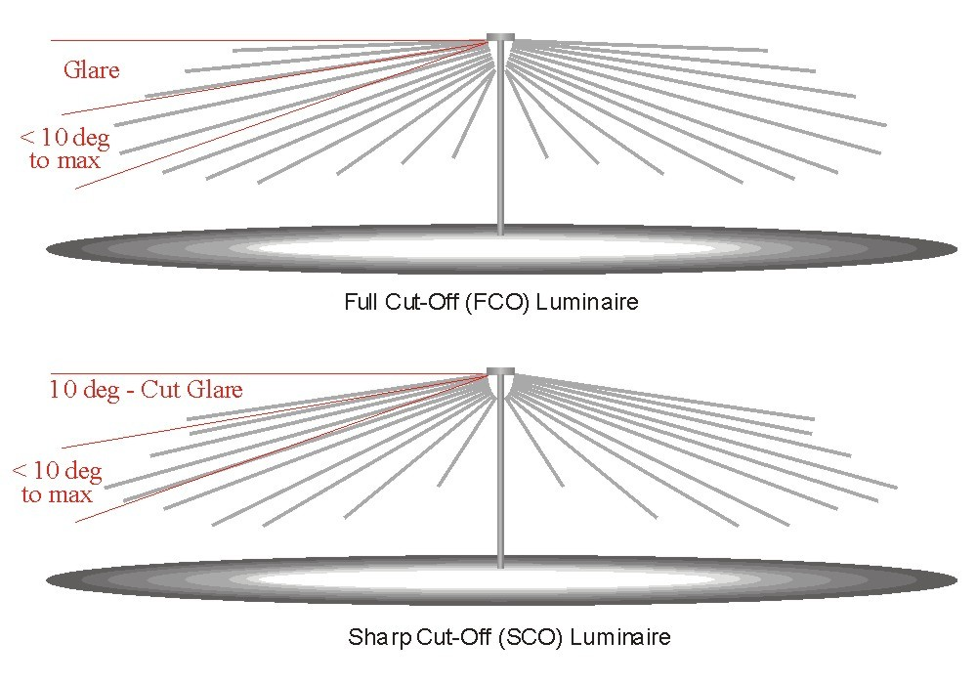
<10% total light output
<1% total light output

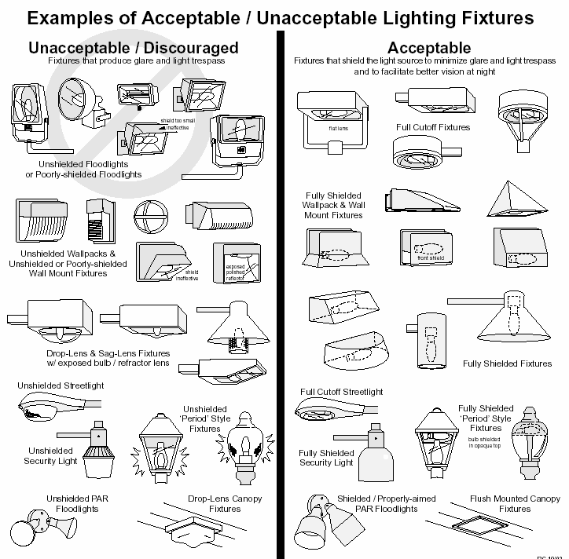
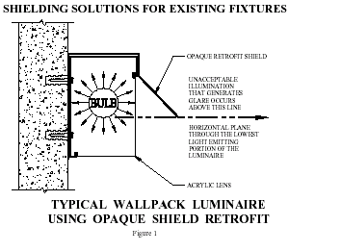

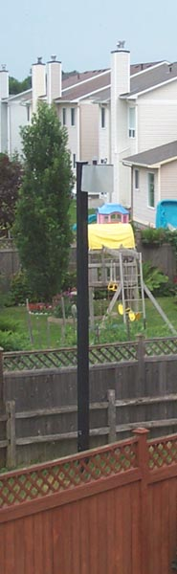

Shielding Solution for existing Street lamp – Kanata Ontario - 2003

The following sources of illumination have been rated by preferential order for outdoor use:
Amber LED 1 - Recommended
<3000K CCT LED 2 - Recommended
High Pressure Sodium (HPS) 3 - Acceptable
>3000K CCT LED 4 - Requires enhanced better shielding
Fluorescent (CCT<3000K) 5 - Requires enhanced better shielding
Other HID Lamps 6
Incandescent 7 - Recommended for very low illumination
Notes:
HID sources include mercury vapor, metal halide, high-pressure sodium and low-pressure sodium. The benefits of HID sources are their high efficacy in lumens per watt and long lamp life (20,000 hours). HID is also a point source, which provides the opportunity for better light control. Light can be better directed where it is needed.
Most lamps on the market today can be categorized into three groups: LED, high intensity discharge (HID), fluorescent and incandescent. LED is solid state lighting. When designed and installed properly it can reduce energy consumption to significantly less than incandescent bulbs and vintage HID lamps. They allow "instant-on" and are easily dimmed. They are available in a range of CCT from <2000K to more than 6500K. The greater the CCT, the greater the emission of biologically harmful blue light
- Amber LEDs emit no biologically harmful blue light. It resembles the colour of typical HPS lamps but provides about 2X the colour rendering of HPS.
- 3000K LED resembles the colour of white incandescent light. About 10% (low) of its emitted light is biologically harmful. It provides 3-4X the colour rendering of typical HPS lamps
- High Pressure Sodium (HPS) also HID, is used in the standard street light luminaire – accepted when fixture is a Full-Cut-Off Fixture. The CCT for HPS can vary but is typically ~2000K. HPS lamps emit about 10% (low) of its lights as harmful blue light
- >3000K CCT lamps appear cool or cold white. They emit >>10% of their light as biologically harmful blue light. The relatively large amount of blue light also magnifies the impact of glare.
- Fluorescent light – normally incandescent is preferred for the warmer white light and is accepted if shielded.
- Other HID lights (Metal Halide) provide a "cool-cold" white light. and >>10% of their light are biologically harmful. They are used where cool white sources are requires such as retail lighting. These should be in totally enclosed luminaires with ShCO shielding to minimize their enhanced effect of glare.
- Incandescent lights are accepted if they are low wattage and fully shielded. It should be noted that warm white natural lights are usually preferred over fluorescent lights. Note also that for outdoor applications, these are less efficient than HPS or LPS .Incandescent emits very little biologically harmful blue light
APPENDIX 2
TABLE 1
The following IESNA standards have been adapted for outdoor lighting and light levels in Mississippi Mills. These values serve as design guidelines when considering development of new outdoor lighting as well as standard criteria when measuring existing areas of outdoor illumination.

To save energy and reduce the amount of glare and light trespass, illumination levels should be closer to the lower levels in the range where possible.

Roadway Lighting | Average Maintained Illuminance (lux) | Uniformity Ratio
Major Road | 6 – 16 | 3:1
Collector Road | 4 – 11 | 4:1
Local Road | 3 – 8 | 6:1
Public Spaces and Usage Levels | Horizontal Illuminance (lux) | Uniformity Ratio
Community Shopping Centres  Cultural, Civic or Recreational Events  Office Parking  Airports, Commuter Lots, etc.  Residential Complex Parking  Hospital Parking | 6 – 24 | 4:1
Neighbourhood Shopping  Industrial Employee Parking  Educational Facilities  Churches | 2 – 8 | 4:1

TABLE 2
Outdoor Illumination Control for Designated Nature Conservation Areas
Table 2 details unshielded or inappropriate outdoor lighting sources which shall not be permitted within four (4) kilometers of DNCA.

Lighting Requirements | Within 4km radius of DNCA
Illuminated Signs | Prohibited
NON-Full Cutoff Cobra | Prohibited
Pole Spacing Ratio < 10 | Prohibited

APPENDIX 3

Light Output from Typical Bulbs for Comparison Purposes
(Compiled by the Royal Astronomical Society of Canada and the International Darksky Association)

Bulb Types | Lumens | Lux at 6 m | Lux at 2 m | Lux at 1 m
Incandescent*  7 watt  15 watt  40 watt  60 watt  100 watt  Metal Halide (MH)  70 watt  100 watt  High Pressure Sodium (HPS)  35 watts  50 watts  70 watts  100 watts  Low Pressure Sodium (LPS)  18 watts  35 watts  55 watts  Compact Florescent (CF)  9 watt (40 w equivalent)  13 watt (60 w equivalent)  LED**  1 watt (White) ***  1 watt (amber) ***  3 watt amber A19**  3 watt amber PAR16**  7 watt amber PAR30**  13 watt amber - PAR38** | 60  128  342  513  855  3,000  5,800  2025  3600  5450  8550  1570  4000  6655  550  850  100  75  90  90  200  400 | 0.13  0.28  0.8  1.1  1.9  6.6  12.8  4.5  8.0  12.1  18.9  3.5  8.8  14.7  1.2  1.9  2.8  2.  0.5  1.8  5.5  11 | 1.2  2.6  6.8  10.2  17.0  59.7  115.4  40.3  71.6  108.4  170.1  31.2  79.6  132.4  10.9  17.9  25  19  4.0  16  50  100 | 4.8  10.2  27.2  40.8  68.0  238.7  461.6  161.1  286.5  433.7  680.4  124.9  318.3  529.6  43.8  71.6  100  75  12  50  200  400
Note: Fixture and bulb degradation before cleaning or replacement may decrease these to as low as 50%.
* The luminous efficiency of incandescent light is approximated as 1/10 that of HPS for photopic vision
** Supplied by IDA
*** Assumes a 1 steradian illumination angle and no external optics, typical for 2011
 Lumens is the total amount of light emitted in all directions (over 4π steradians)
 Lux is the amount of light illuminating a surface of one metre square
1 lux = 1 Lumen / (4π dist²) where distance is in metres
References:
IDA Information Sheet 4, Operating Data and Economics of Different Lamps, (08/96)
CAN/CSA-C653-94 (2000) - Performance Standard for Roadway Lighting Luminaires
Mesopic Street Lighting Demonstration, Lighting Research Centre, Jan. 31, 2008, (Rensseaer), Table 2, 5

APPENDIX 4

Illumination of Advertising Signs
